**Measure Of Central Tendency**

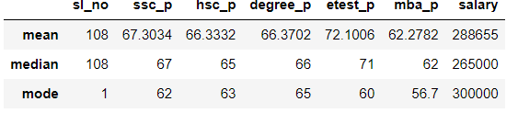

**Mean :**

The mean value for ssc _p in overall 108 students get Average value = 67.3034

The mean value for hsc _p in overall 108 students get Average value = 66.3332

The mean value for degree _p in overall 108 students get Average value = 66.3034

The mean value for etest _p in overall 108 students get Good = 72.1006

The mean value for mba _p in overall 108 students get Average = 62.2784

The mean value for salary in overall 108 students get average = 288655

**Median :**

The mean value for ssc_p in overall 108 students get Average value = 67

The mean value for hsc_p in overall 108 students get Average value = 65

The mean value for degree_p in overall 108 students get Average value = 66

The mean value for etest_p in overall 108 students get Good = 71

The mean value for mba_p in overall 108 students get Average = 62

The mean value for salary in overall 108 students get average = 265000

**Mode:**

In ssc_p overall students get upto 67% in this the repeated obtained mark is 62

In hsc_p overall students get upto 65% in this the repeated obtained mark is 63

In degree_p overall students get upto 66% in this the repeated obtained mark is 65

In etest_p overall students get upto 67% in this the repeated obtained mark is 60

In mba_p overall students get upto 67% in this the repeated obtained mark is 56.7

In salary according to overall students mark most repeated got salary is 300000

**Percentile**



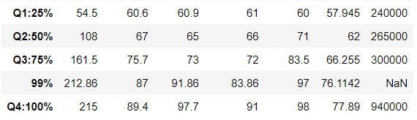

**Ssc _p:**

The difference between Q1:25% and Q2:50% is 7%

The difference between Q2:50% and Q3:75% is 8%

The difference between Q3:75% and 99% is 12%

The difference between 99% and Q4:100% is 2%

hsc_p:

The difference between Q1:25% and Q2:50% is 5%

The difference between Q2:50% and Q3:75% is 8%

The difference between Q3:75% and 99% is 14%

The difference between 99% and Q4:100% is 6%

degree_p:

The difference between Q1:25% and Q2:50% is 5%

The difference between Q2:50% and Q3:75% is 6%

The difference between Q3:75% and 99% is 11%

The difference between 99% and Q4:100% is 8%

etest_p:

The difference between Q1:25% and Q2:50% is 11%

The difference between Q2:50% and Q3:75% is 12%

The difference between Q3:75% and 99% is 14%

The difference between 99% and Q4:100% is 1%

Salary:

The difference between Q1:25% and Q2:50% is 2lakhs

The difference between Q2:50% and Q3:75% is 4lakhs

The difference between Q3:75% and Q4:100% is 54lakhs

**Inter Quartile Percentile**



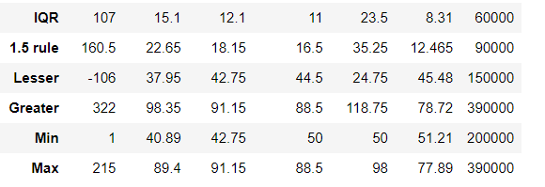

**IQR:**

By taking Q3:75% - Q1:25% we get all IQR values i.e for ssc_p = 15.1 , hsc_p = 12.1 , degree_p = 11 , etest_p = 23.5 , mba = 8.31 , salary = 60000

1.5 rule:

By calculating 1.5 rule with previous IQR value obtained the following i.e 1.5 rule*IQR for ssc_p = 22.65 , hsc_p = 18.15 , degree_p = 16.5 , etest_p = 35.25 , mba_p = 12.464 , salary = 90000

**Lesser:**

By calculating Lesser outlier with formula Q1:25% - 1.5*IQR i.e for ssc_p = 37.95 , hsc_p = 42.75,degree_p = 44.5 , etest _p = 24.75 , mba_p = 45.48

**Greater:**

By calculating Lesser outlier with formula Q3:75% + 1.5*IQR i.e for ssc_p = 98.35 , hsc_p = 91.15,degree_p = 88.5 , etest _p = 118.75 , mba_p = 78.72

**Min:**

By calculating min value for ssc_p the value exist greater than the lesser range value

By calculating min value for hsc_p the value does not exist lesser range value

By calculating min value for degree_p the value exist greater than the lesser range value

By calculating min value for etest_p the value exist greater than the lesser range value

By calculating min value for mba_p the value exist greater than the lesser range value

**In this case we’ll use outlier to summaries the values in their existing range**

**Max:**

By calculating max value for ssc_p the value exist lesser than the range value

By calculating min value for hsc_p the value exist in equal range

By calculating min value for degree_p the value exist in equal range

By calculating min value for etest_p the value exist lesser than the range value

By calculating min value for mba_p the value exist lesser than the range value